NORFOLK COUNTY COUNCIL proposes to make a Temporary Traffic Order affecting the C118 North Pickenham Road from its junction with A47 Norwich Road for 375m southwards in the PARISH OF SPORLE WITH PALGRAVE because of Anglian Water works to install a double boundary box.

The road will be temporarily closed (except for access) from 11th to 13th January 2022 for the duration of the works expected to be about 3 days within the period.

Alternative route is via: North Pickenham Road, Whitegate Road, Swaffham Road, Station Road, School Road, Cook Road, Red Lion Close, Necton Road, Hale Road, Tuns Road, A47 From J A1075/B1135 To Dualling At Swaffham Bypass, Norwich Road (Necton, Holme Hale, North Pickenham, Sporle with Palgrave).

(If necessary the restriction could run for a maximum period of 18 months from the date of the Order).

Penalty: £1000 maximum fine on conviction and/or endorsement for contravention.

In the event of the start date being delayed the new start date will be displayed on site in advance.

The person dealing with enquiries at Norfolk County Council is Harvey Woodyatt (Community and Environmental Services) Telephone 0344 800 8020.

Dated this 24th day of December 2021

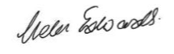

Helen Edwards

Chief Legal Officer

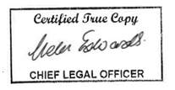

County Hall

Martineau Lane

Norwich

NR1 2DH

