NORFOLK COUNTY COUNCIL proposes to make a Temporary Traffic Order affecting the U33239 Browns Lane for 20m in both directions from its junction with Houghton Lane in the PARISH OF NORTH PICKENHAM because of Openreach works.

The road will be temporarily closed (except for access) between 09:30 and 15:30 from 12th to 14th January 2022 for the duration of the works expected to be about 3 days within the period.

Alternative route is via: Browns Lane, Watton Road, The Street, West View, Road from South Pickenham to North Pickenham, South Pickenham Road, Houghton Lane, Station Road, Swaffham Road, North Pickenham Road, Hillside (Holme Hale, South Pickenham, North Pickenham).

(If necessary the restriction could run for a maximum period of 18 months from the date of the Order).

Penalty: £1000 maximum fine on conviction and/or endorsement for contravention.

In the event of the start date being delayed the new start date will be displayed on site in advance.

The person dealing with enquiries at Norfolk County Council is Harvey Woodyatt (Community and Environmental Services) Telephone 0344 800 8020.

Dated this 24th day of December 2021

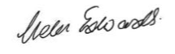

Helen Edwards

Chief Legal Officer

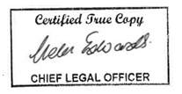

County Hall

Martineau Lane

Norwich

NR1 2DH

