NORFOLK COUNTY COUNCIL proposes to make a Temporary Traffic Order affecting the U33238 North Pickenham Road from 80m south of its junction with U31185 Jubilee Way for 40m southwards in the PARISH OF NECTON because of a new water main.

The road will be temporarily closed (except for access) from 4th to 5th January 2022 for the duration of the works expected to be about 2 days within the period.

Alternative route is via: U33238 North Pickenham Road/Browns Lane, C116 Station Road, C117 School Road/Cook Road/Necton Road/Hale Road and vice versa (Necton, Holme Hale).

(If necessary the restriction could run for a maximum period of 18 months from the date of the Order).

Penalty: £1000 maximum fine on conviction and/or endorsement for contravention.

In the event of the start date being delayed the new start date will be displayed on site in advance.

The person dealing with enquiries at Norfolk County Council is Harvey Woodyatt (Community and Environmental Services) Telephone 0344 800 8020.

Dated this 17th day of December 2021

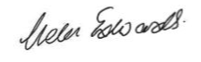

Helen Edwards

Chief Legal Officer

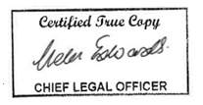

County Hall

Martineau Lane

Norwich

NR1 2DH

Map and plan of road closure and alternative diversion route